DECISION CRITERIA
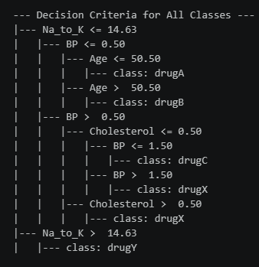

Think of this decision tree as an automated medical flow chart. It acts like a doctor asking a sequence of "Yes or No" questions to safely sort patients into the correct prescription drug category (drugA, drugB, drugC, drugX, or drugY).
Here is exactly how the model thinks, broken down step-by-step:

Step-by-Step Logic

1. The Ultimate Filter (Na_to_K ratio)
- If Na_to_K > 14.63: The check stops. The patient is prescribed drugY.

- If Na_to_K <= 14.63: The model moves to the next check.

2. High Blood Pressure Branch (BP <= 0.50 (High BP)
If the patient has a low ratio and High BP, the model splits by Age:
- Age 50 or younger: Prescribed drugA.

- Older than 50: Prescribed drugB.

3. Low or Normal Blood Pressure Branch (BP > 0.50 (Low or Normal BP)
If the patient has a low ratio and Low/Normal BP, the model looks at Cholesterol:
- If Cholesterol is HIGH (Cholesterol <= 0.50):

- If Low BP (BP <= 1.50): Prescribed drugC.

- If Normal BP (BP > 1.50): Prescribed drugX.

- If Cholesterol is NORMAL (Cholesterol > 0.50): Automatically prescribed drugX.

Corrected Summary Checklist
If the patient has... | ...they get prescribed:
High Sodium-to-Potassium ratio (> 14.63) | drugY
Low ratio + High BP + Age \(\le \) 50 | drugA
Low ratio + High BP + Age > 50 | drugB
Low ratio + Low BP + High Cholesterol | drugC
Low ratio + Normal BP OR Normal Cholesterol | drugX

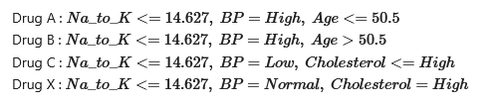

DECISION TREE CLASSIFIER
